**Ex1:**

data <- mpg

glimpse(data)

**Ex2:**

ggplot(data=mpg, mapping=aes(x=cty, y=hwy, color=class))+geom_point()+labs(title="City Miles Per Hour VS Highway Miles Per Gallon (hwy)")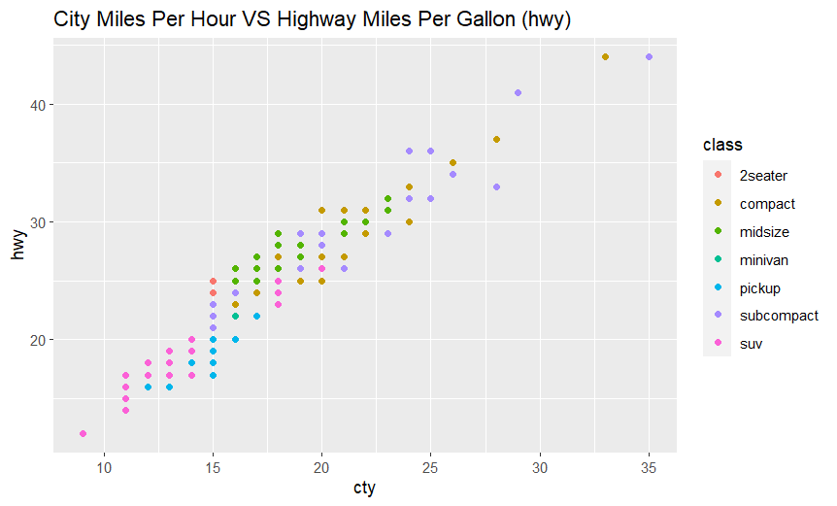

**Ex3:**

ggplot(data=mpg, mapping=aes(x=cty, y=hwy, color=class))+geom_jitter()+labs(title="City Miles Per Hour VS Highway Miles Per Gallon (hwy)")

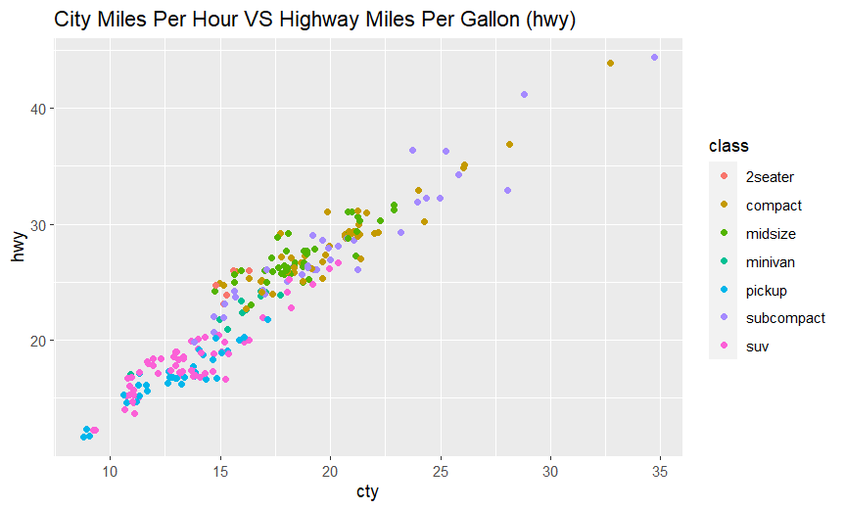

* geom_point:

Advantages:

Simple and clear way to visualize points on a plot

Easy to control point aesthetics like color, size, shape

Disadvantages:

Points can overlap if there are many observations in the same location

Overlapping points make it hard to see density or count of observations

* geom_jitter:

Advantages:

Prevents overlapping of points by adding random noise/jitter to the points

Better for dense datasets as it shows underlying patterns and density clearly

Can still see individual observations unlike geom_density()

Disadvantages:

Adds random noise so exact positions are approximations rather than true values

Less precise than geom_point if seeing exact positions is important

More cluttered looking than geom_point if there are many points

**Ex4:**

ggplot(data=mpg, mapping=aes(x=cty, y=hwy, color=class))+geom_jitter()+labs(title="City Miles Per Hour VS Highway Miles Per Gallon (hwy)")+facet_wrap(drv~.)

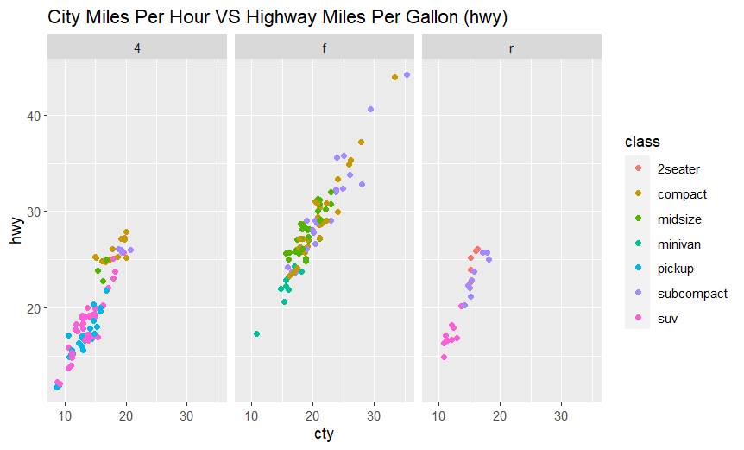

A car's class clearly impacts its city MPG (cty). Larger vehicles like SUVs, trucks and vans get fewer cty MPG than smaller cars. The connection between class and cty MPG seems non-linear, with SUVs lowest and tiny two-seaters highest.

**Ex5:**

ggplot(data=mpg, mapping=aes(x=cty, y=hwy, color=class))+geom_jitter()+labs(title="City Miles Per Hour VS Highway Miles Per Gallon, MN", x= "City Miles Per Gallon (cty)", y="Highway Miles Per Gallon(hwy)")+facet_wrap(drv~.)

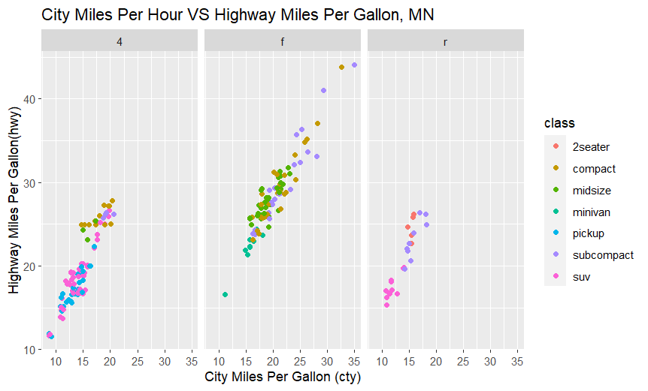

The relationship between city and highway MPG for different vehicle classes. Larger vehicles have lower city MPG than smaller ones. There is a non-linear link between class and city MPG. City MPG also varies significantly within each class.

**Ex6:**

ggplot(data=mpg, aes(x=cty, y=class, color=class))+geom_boxplot()

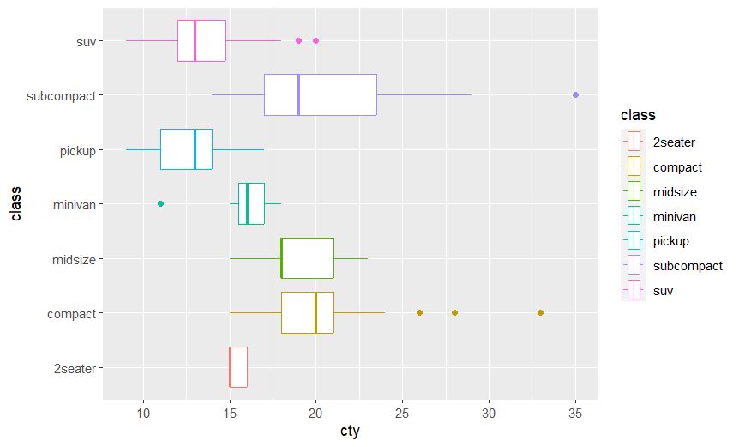

**Ex7:**

ggplot(data=mpg)+geom_bar(mapping=aes(x=class, fill=drv))+coord_flip()+labs(title="Class VS Drive Train", x="Class")

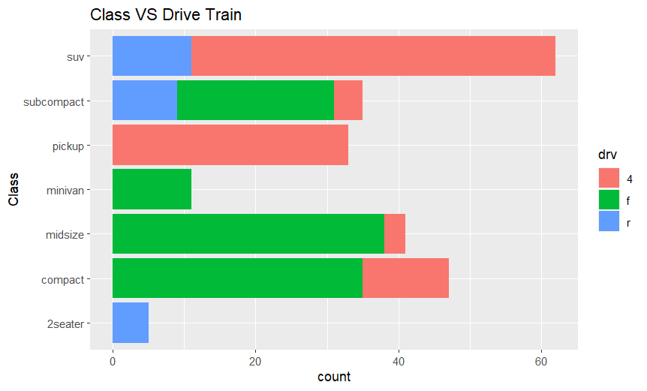

**Ex8:**

mpg <- mpg %>%

rename(vehicle_class = class)

ggplot(data=mpg, mapping=aes(x=displ, y=hwy))+geom_point(size=0.5)+labs(title="Highway mpg VS Displacement",x="Displacement (Litres)", y="Highway mpg")+theme_bw()facet_wrap(~vehicle_class, nrow=2)

